**20 Pips Per Day**

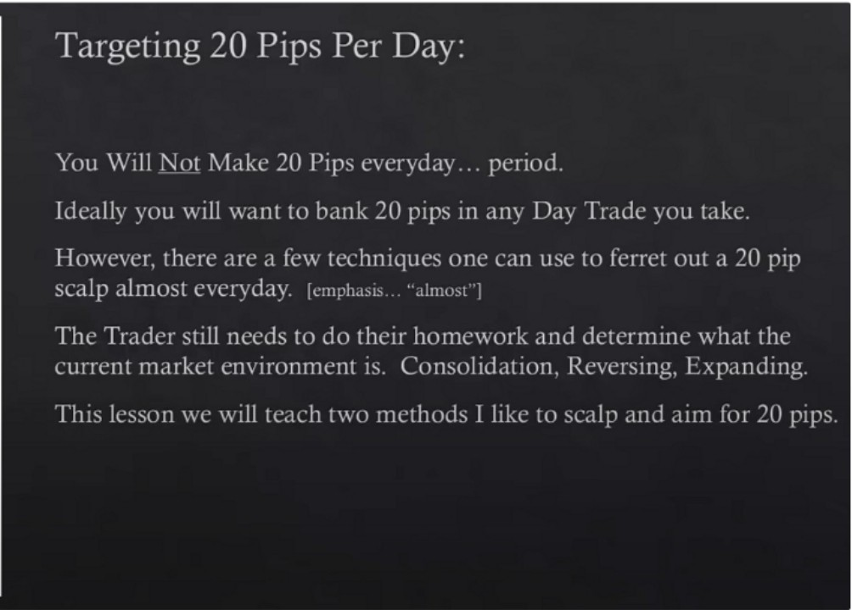

**2**

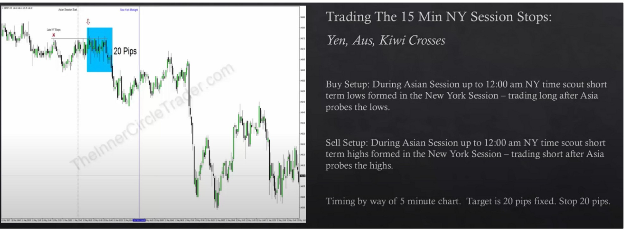

- ---



f,.;,\v - •,

/

' ..., ,, 11 ·

Turtle soup setups

Youre basically prcing in the high/low of the asian range

Notice how it takes a high so it goes into a premium array then targets a discount array ICT likes to short 5 pips above a high

On a bullish continuation day these sell setups work maybe even better, because you're essentially trading the judas swing down to then go up in london, we already anticipate an asian range that wants to trade lower ahead of a bullish day. Or if the move starts a little bit sooner then MNO it could trade down make the judas swing there and give you your 20 pips before it starts to go higher and make the higher close on the day without really requiring a london session judas swing

So we trade in the 8pm to MNO time window

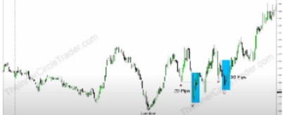

London likely created the HOD, new york has a little retracement higher it trades above a short term 5m high

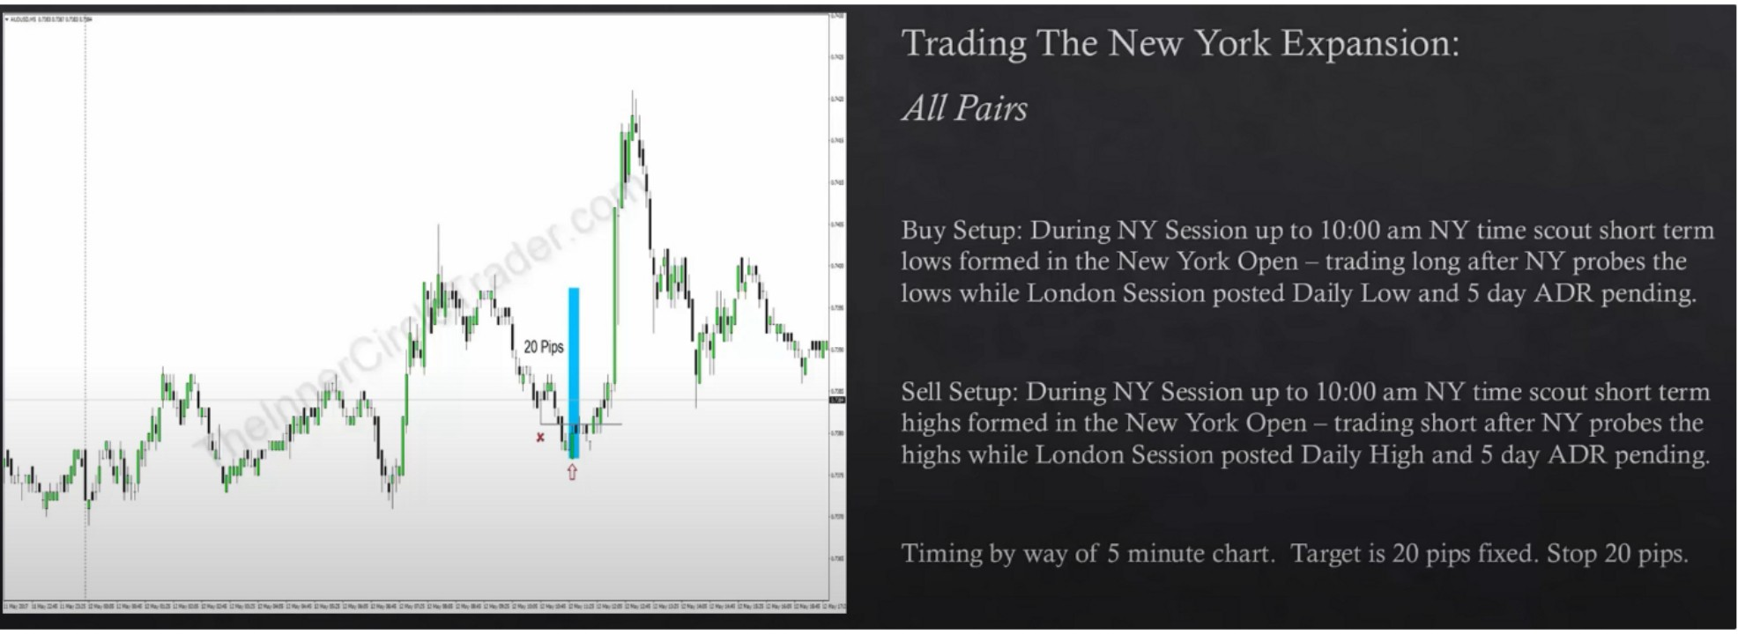

Also trades into a FVG and orderblock on the first example Sometimes you can get multiple setups

You have to have a strong conviction of what london has already done

This pattern works great on SP500 and other indices as well and futures like ES ofcourse, he doesnt recommend daytrading stocks because it doesnt have high volatility

Arjo I Twitter, lnstagram I Linktree

Linktree. Make your link do more.

, https://t.co/HhmmTN1fUI

JavaScript is not available.

*"!JI* https://twitter.com/arjoio